**Enable Configurable Behavior With Plugin**

|  |  |  |
| --- | --- | --- |
| *instances of a class require configurable behavior* |  | *extract an interface for the pluggable behavior and have instances by default configured with a NullObject implementation* |

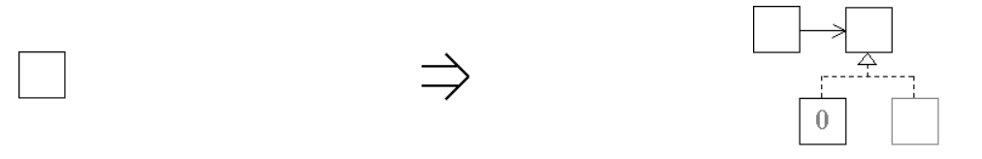

**Context:**  
[Enable Configurable Behavior With Plugin](https://web.archive.org/web/20090914084943/http:/www.refactoring.be/thumbnails/rtn-ecbwp.html) is a variation on [Enable Substitution With Interfaces](https://web.archive.org/web/20090914084943/http:/www.refactoring.be/thumbnails/rtn-eswi.html) where the substitution allows the context class to be configured with an external implementation of a given interface. Configuring the default implementation with a NullObject relieves the context class from having to deal with the variation between a null referenc and given plugin.